

Dr. Troy, Schmidt inc.
2019-03-13
Dr. Schmidt
963 Noah Terrace, South Ashleyfort, RI 75755
Phone: 8839023318
Fax: 5371236889

Re: Gina, Romero
PHN: 534911592
Birthdate: 08-Nov-1992
Address: 57035 Kathryn Isle, Fredview, TX 82768
Patient number: 6923235440

To Whom It May Concern:

This is a medical letter to state the above patient is pregnant with expected delivery date of 25-Feb-2025. Hoping this information is satisfactory for your requirements.

Thank you.

Sincerely,
Dr. Troy, Schmidt
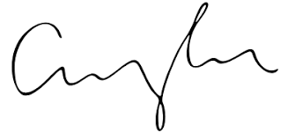
FRCS© NCMP
Clinical Assistant Professor, UBC
Department of Obstetrics and Gynecology SMH

